RESUME ADDENDUM

Aircraft Experience
Steven C. Buren

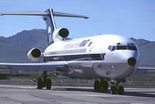 727
Overhaul of Desert Dinosaurs to modern interior, APU, and radio upgrades for sale to Argentina and Brazil.

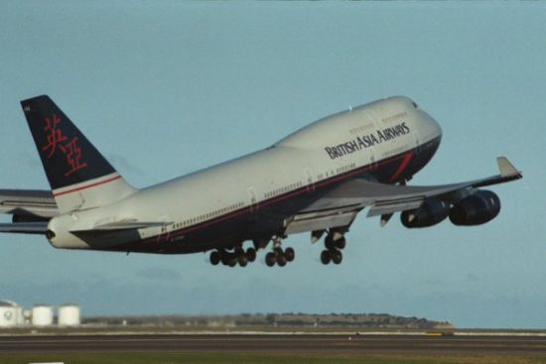 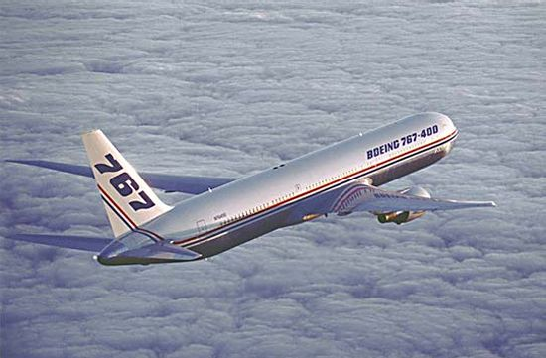 747, 767
747- 100, Converted from passenger to cargo aircraft.

747- 400 & 767 Modified new aircraft with a complete custom interior for Sultan of Brunei as a part of U.S. Oil trade negotiation.

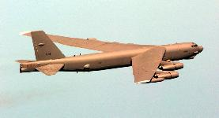 B-52
Water Injection control upgrade to prevent individual pod cutoff that resulted in thrust imbalance.
Complete Inertial Navigation replacement from Analog gear calculator & Vacuum tube amplifier system to Laser-Ring-Gyro with terrain follower controls.

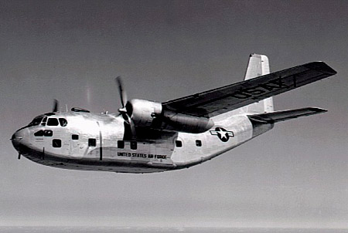 C-123
Loran-C and radios upgrade for Reserve Trainers.

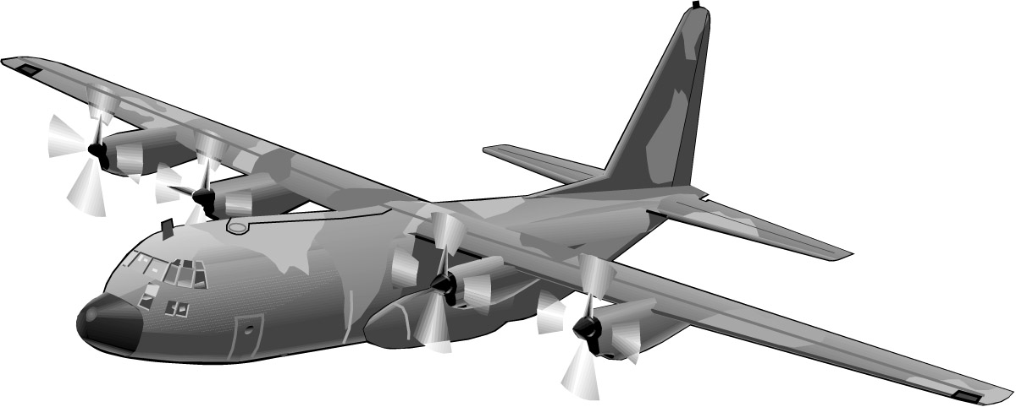 C-130
Bleed-Air-overheat sensors installed on leading edges, with Loran-C and color radar upgrade.
Sole Site Electrician on Fuel-cell overhaul facility for 15 months. Complete change of wire type on some wing tanks, with test, repair, calibration, and upgrade of all fuel system components.
Inertial Navigation, radar, and radios upgrade with dual touch-screen controllers. Power Distribution rebalancing and wiring upgrade.

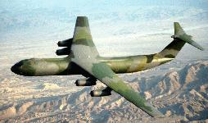 C-141
Inertial navigation radar interface, for long-range formation flying. Upgrade of Krypto-voice and navigation systems recorders.

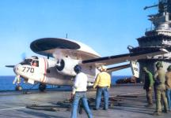 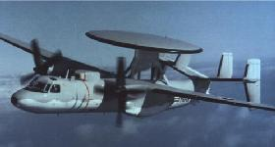 E-1, E-2
Aircraft Electrician in U.S. Navy, assigned to E-2 radar Aircraft. Complete Maintenance and Inspection of all electrical systems, excluding radar and radios. Engine changes, Wing Changes, Inertial Navigation, all Instrument Panel Indicators, circuit breaker & power distribution panels, generators and associated wiring. Pneumatic and hydraulic controllers, landing gear and control surfaces.
Aircraft Carrier - Independence, flight deck electrician on two cruises with VAW-122 Squadron of four aircraft.
Worked with and trained Navy Reserve Technicians on E-1 and E-2 aircraft while shore based between cruises, in addition to maintaining our squadron aircraft.

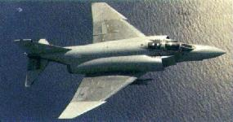 F-4
Three years of complete upgrades and overhaul of engines, avionics, video recorders, and control surfaces in a multiple modification and repair site. Served multiple roles as Technician, Mechanic, Installer, Inspector, and Troubleshooter.
One notable event was a seven straight (ZD)-Zero Defect, Post-Mod inspection by the local Air Force team, (Homestead, Fl.) This record concerned the Warner-Robins records center into sending an evaluation team to verify that aged aircraft were getting unblemished repairs and upgrades. Their findings resulted in expansion of our contract to multiple facilities and copying some of our methods to contract standards.
Navigations modification for a remote autopilot control system, and a programmable cartridge course map system.

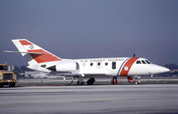 HU-25
Complete assembly of the first 13 aircraft produced for the Coast Guard. Worked with one of three assembly teams. Each team in Little Rock, received a Falcon-20 modular shell from Dassault France, modified the structure, then installed all wiring and systems, up to completion and first flight. At completion, the team then received another shell and worked again to completion. The Coast Guard contract was extended to 21 aircraft, but our sub-contract (Lear Siegler) was completed at 13 aircraft.

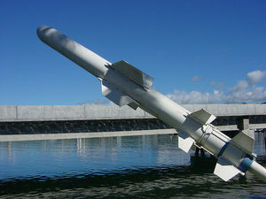 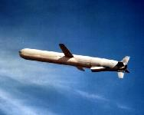 Harpoon & Cruise Missiles
Worked with McDonnell Douglas Corporation on bench assembly of Harpoon Missile wiring harnesses and starter systems. Assembled test & control panels for Missile launch systems. Bench assembly of Cruise Missile guidance system.

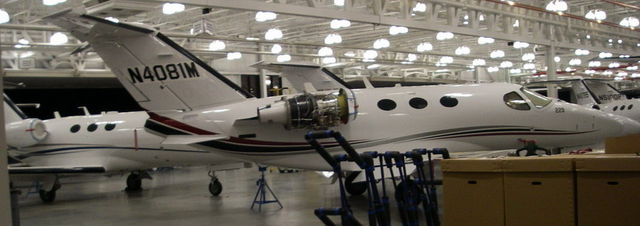 Mustang
Cessna’s smallest Business Jet, 6-passenger. Complete buildup & testing to flight line operations. Garmin G-1000 instrument panel installation & maintenance programming.

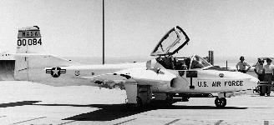 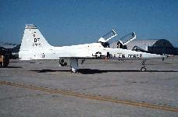 T-37, T-38
Engine changes and intake modification on T-37 for oscillating noise reduction. Changed seats, canopy and instrument panels. Radio upgrade on T-38. Painting on both aircraft.

